

24 – 26 May 2022

Kuala Lumpur Convention Centre

Level 4, Hall 8A – 8C

Exhibitor Toolkit

# **INDEX…..**

1. General Information 1-1. Location Information P 3

1-2. Loading Bay P 4

1-3. Emergency & Evacuation Procedures P 5

1-3. Important Contacts P 6

1. Schedule & Access 2-1. Events Hour P 7

2-2. Appendix P 8

2-3. Badges & Contractor Pass P 8

1. Constructions 3-1. Shell Scheme Package P 9

3-2. Contractor & Height Restriction P 10

3-3. Electrical Regulation P 10

3-4. Non official contractor (Form 1) P 11

3-5. Performance Bond approval form P 12

3-6. Other Technical Service P 13

3-7. Construction Policies P 13 -14

1. Rules & Regulation 4-1. Basic Rules P 15-19

4-2. Do & Don’t for Exhibitors P 20

4-3. Product Sampling & Sales P 21

4-4. Cautions P 21

4.5. Covid-19 & Emergency Cases P 22

4-6. Cancellation & Postponement P 23

1. Exhibitors Service 5-1. Check List for order form P 24

5-2. Fascia Name - Shell Scheme (Form 2) P 25

5-3. Furniture (Form 3) P 26-27

5-4. Electrical Order (Form 4 & Form 4B) P 28-30

5-5. Graphic Printing (Form 5) P 31-34

1. KLCC Service Form Kuala Lumpur Convention Centre Exhibitor Online Order Forms P 35-36

**General Information**

* 1. **Location**

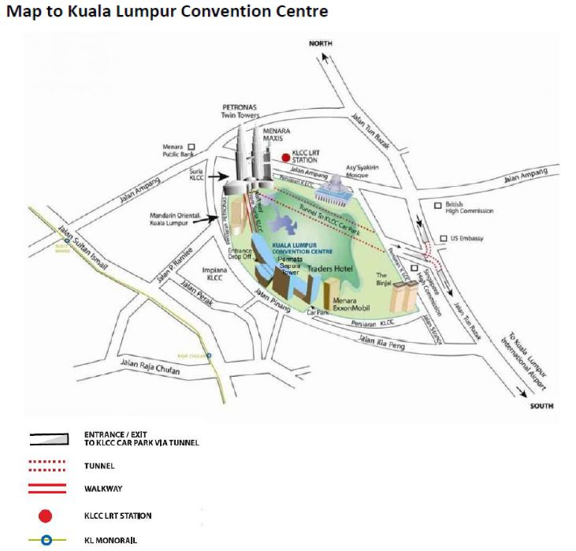

For more information on how to get to KLCC, please click on the link below:

<https://www.klccconventioncentre.com/clients/asset_1D27A8C6-DE8C-4066-B3D8-0593D73C0267/contentms/img/pdf/Transportation-Guide_2021.pdf>

* 1. **Loading Bay**

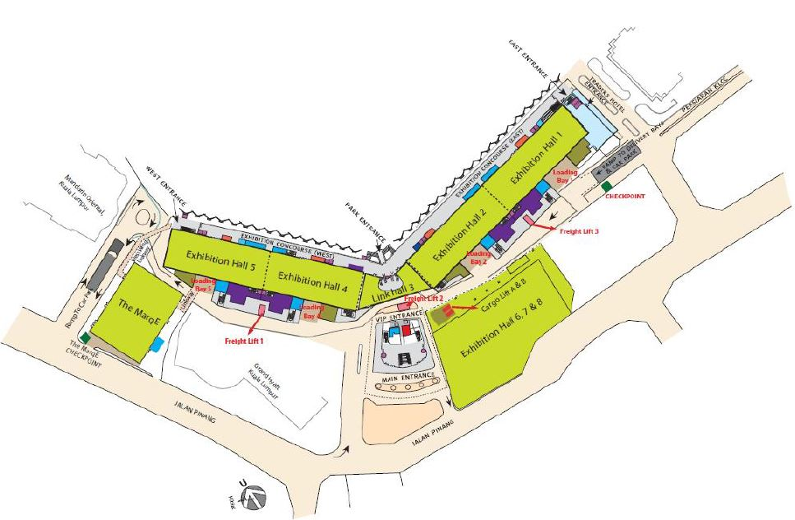

**General Guidelines Access to Loading Bays**

* The Centre’s loading bay is located on the ground floor.
* Control point is at the Centre’s checkpoint (adjacent to Traders Hotel).
* Traffic flows in a one-way direction, enter from Persiaran KLCC and exit to Jalan Pinang.
* The loading bay service road is 8 metres in height and 6 metres in width at Loading Bay 1 and Loading Bay 2, with narrower sections behind the service road of Link Hall 3 and Loading Bay 4 and Loading Bay 5. The narrow section behind Link Hall 3 has a low ceiling of only 4 metres in height. Safety goal posts of 4 metres in height are installed before and after the service road of Link Hall 3.
* Only vehicles below 3.5 metres in height are allowed access to the loading bay service road.
* A 30-minute parking limit applies for drop-off/pick-up of goods during the move-in and move-out process. Vehicles are not permitted to park at the loading bays at any other time.
* Vehicles and their contents are the responsibility of the owner while at the loading bays.
* The Loading Bay area includes two paint washrooms for cleaning purposes, one located at Loading Bay 2 and the other at Loading Bay 4.
* Due to the potential risks and dangers from the high level of activities during move-in/move-out process, only workers, exhibitors, contractors are only allowed at the loading bay during this period. Other people are strictly allowed.
* The unloading and loading of exhibitor materials for use in the exhibition halls should be conducted within the Loading Bay area only. Loading or unloading of exhibit materials through any other door is prohibited.
* Equipment/goods cannot be moved out via front of house areas. This includes the main entrance, the door steps of Exhibition Hall 1, Exhibition Hall 5 and Atrium Hall 6.
  1. **Evacuation Assembly Area**

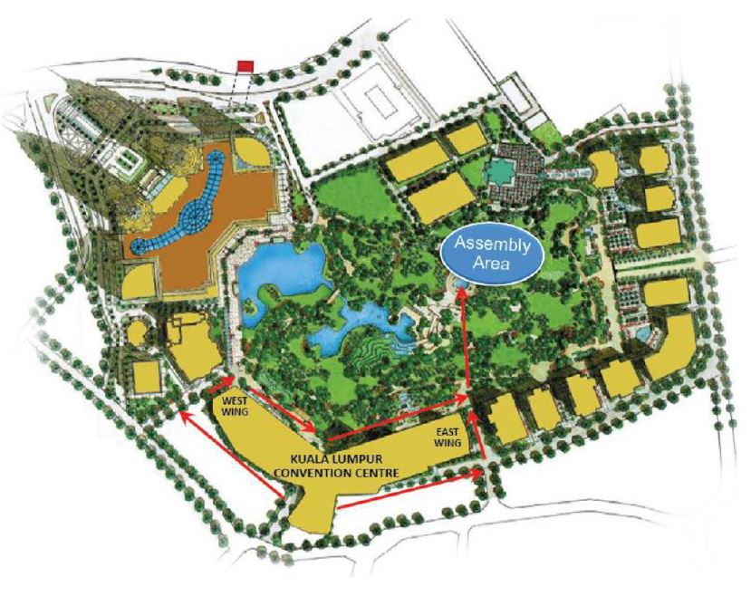

* Emergency & Evacuation Procedures

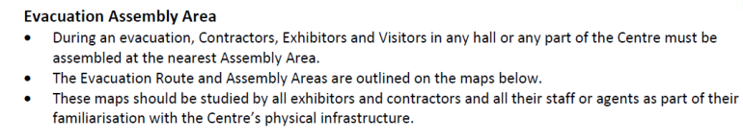

* Emergency Contact Number – Dial 555 (by using inhouse telephone) or +603 2333 2900(by using mobile phone)
* Assembly Map- As attached
  1. **Important Contacts**

**Venue**

**Kuala Lumpur Convention Centre**

Kuala Lumpur City Centre, 50088 Kuala Lumpur Malaysia

Office Tel: +60 3 2333 2603

Website: www.klccconvetioncentre.com

**Exhibitor Services Centre (ESC)**

Direct Line: +60 3 2333 2603

Email: exhservices@klccconventioncentre.com

**Official Contractor**



**Knoxx Pte Ltd**

51 Tai Seng Avenue, B1-03, Pixel Red, 533941

Tel: (65) 6904 2498 Fax: (65) 6904 2484

Website: www.knoxx.com.sg

|  |  |
| --- | --- |
| **Colin Tan** | **Raymond Sim** |
| Project Director | Assistant Project Manager |
| Email: [ws@knoxx.com.sg](mailto:ws@knoxx.com.sg) | Email: [rs@knoxx.com.sg](mailto:rs@knoxx.com.sg) |

**OFFICIAL FREIGHT FORWARDER**



**Meritex International Freight Services Ltd**

United Kingdom

Website: [www.meritex.co.uk](http://www.meritex.co.uk)

Tel: +44 (0)1392 454999

Fax: +44 (0)1392 454998

|  |  |
| --- | --- |
| **Dan Sweet** | **Rasa Margyte** |
| Email: [dan@meritex.co.uk](mailto:dan@meritex.co.uk) | Email: [rasa@meritex.co.uk](mailto:rasa@meritex.co.uk) |

**Schedule & Access**

* 1. **Operation Hours**

Build-Up (Sunday - Monday, 22 – 23 May 2022)

|  |  |  |
| --- | --- | --- |
| Schedule | Date | Time |
| Build-up for non-official Contractor | Sunday, 22th May 2022 | 1500 - 2200hrs |
| Monday, 23th May 2022 | 1000 - 1800hrs |
| Shell Scheme Booth Exhibitor move-in | Monday, 23th May 2022 | 1000 - 1800hrs |
| Official Freight Forwarder move-in | Monday, 23th May 2022 | 1000 - 1800hrs |

Official Show Days (Tuesday – Thursday, 24 – 26 May 2022)

|  |  |  |
| --- | --- | --- |
| Schedule | Date | Time |
| Show Days Opening Hours | Tuesday, 24th May 2022 | 1000 – 1800hrs |
| Wednesday, 25th May 2022 | 1000 - 1800hrs |
| Thursday, 26th May 2022 | 0900 - 1300hrs |

Teardown (Thursday, 26th May 2022)

|  |  |  |
| --- | --- | --- |
| Schedule | Date | Time |
| Exhibitor move-out | Thursday, 26th May 2022 | 1300 – 1500hrs |
| Official & Non-Official Contractor Teardown | 1300 – 2200hrs |
| Official Freight Forwarder move-out |  | 1300 – 2200hrs |

Registration (Sunday - Thursday, 22 - 26 May 2022)

|  |  |  |
| --- | --- | --- |
| Schedule | Date | Time |
| All Registration Open | Sunday, 22th May 2022 | 1630 – 1800hrs |
| Monday, 23th May 2022 | 0700 - 1200 & 1330 - 1800hrs |
| Tuesday, 24th May 2022 | 0730 - 1800hrs |
| Wednesday, 25th May 2022 | 0800 - 1800hrs |
| Thursday, 26th May 2022 | 0800 - 1300hrs |

Exhibitor & Contractor Pass/Badge Collection (Monday - Tuesday, 23 - 24 May 2022)

|  |  |  |
| --- | --- | --- |
| Schedule | Date | Time |
| Non-official Contractor | Sunday, 22th May 2022 | 1500 – 1800hrs |
| Monday, 23th May 2022 | 1000 - 1800hrs |
| Exhibitor | Sunday, 22th May 2022 | 1500 – 1800hrs |
| Monday, 23th May 2022 | 1000 - 1800hrs |

* 1. **Appendix**

Freight Arrival

* All cargo sent via the Freight forwarder or Post / Courier service should be planned to arrive at the booth on 23th May 2022 (Monday) after 1000hrs
* All cargo will be handle by the official freight forwarder

Show Hours

* All exhibitors are asked to be fully prepared for the booth operation 30 minutes before the exhibition starts
* Overtime preparation is not permitted during the show days
  1. **Badges & Contractor Pass**

Badge Types

* Exhibitor ・・・ Valid ONLY from 22nd to 26th May 2022
* Contractor ・・・ Valid for constructions & dismantle period **ONLY** (22-23 May & 26 May).

(Contractor Pass to be exchanged directly at Knoxx Site-Office)

Exhibitor Badges

* Each exhibitor will be issued with Exhibitor Badge from the Organizer.
* Each exhibitor and their staff are required to wear exhibitor badge in level 4, Hall 8ABC throughout the entire show duration.
* Exhibitor Badges can be collected at the Registration Counter at Level 4
* Each Badge is not transferable.

Non-Official Contractor Pass

* During the construction and dismantle days, every contractor is required to put on their uniform and Pass.
* Contractor is required to show Identification Card (for Non-Official Contractor) that had been submitted to the Organizer, to exchange for Contractor Pass.
* The Contractor Pass is valid only on the construction period and dismantling period. It cannot be used during the show days.
* Contractor Passes can only be collected by the PIC of each exhibition & event company at Knoxx Site Office
* For Non-Official Contractor Deposit for Special Design booth (refundable Performance Bond, please refer to page 10).
* Admin Fee for Special Design Booth (non-refundable)

Before an Exhibitor Appointed Contractor is allowed to work on site, he must:

* Place a performance bond (refundable).
* Pay an administrative fee (non-refundable).
* Submit the Risk Assessment (RA) and Safe Work Procedures (SWPs) for this specific project, in English language.
* Ensure that all plans are approved by the [Organiser](mailto:mbarton@tamu.edu) and relevant local authorities.
* High visibility vest must be worn at all times during the buildup and teardown period.

|  |  |
| --- | --- |
| Performance Bond  (Refundable) | Administrative Fee  (Non-Refundable) |
| USD$50 per sqm | USD$35 per sqm |

**Constructions**

**3-1. Shell Scheme Package**

**Shell Scheme Stand Specifications**

All packages listed have the following specifications:

The following items are provided with a 3m x 3m Shell Scheme Booth:

1. Walls : White laminated wall partition with fire retardant white board infill
2. Fascia : 210mm (ht) white fascia board c/w Company’s name & stand number in

Red colour Vinyl sticker in Helvetica typeface of respective zone

1. Lighting : 2 nos. 40W fluorescent tubes
2. Furniture : 1 no. white system information counter (1mLx0.5mWx1mH)

1 no. Round Discussion Table

2 nos. white plastic chair and 1 no. wastepaper basket

e) Electrical : 1 no. 13 Amp / 230V single phase power point (fuse to 5amp)

*f) Flooring :* 9sqm single tone needle punch carpet

***\* The above entitlements cannot be interchanged with other items. If exhibitors do not require any of the items, no refund will be given.***

|  |  |  |  |  |  |  |  |  |
| --- | --- | --- | --- | --- | --- | --- | --- | --- |
| **Stand Area in sqm** | **9** | **18** | **27** | **36** | **45** | **54** | **63** | **72** |
| System Information Counter  (1mL x 0.5mW x 0.76mH) | 1 | 2 | 3 | 4 | 5 | 6 | 7 | 8 |
| White Plastic Chair | 2 | 4 | 6 | 8 | 10 | 12 | 14 | 16 |
| Waste Paper Basket | 1 | 2 | 3 | 4 | 5 | 6 | 7 | 8 |
| 40W fluorescent tube | 2 | 4 | 6 | 8 | 10 | 12 | 14 | 16 |
| PowerPoint 13amp s/phase (fuse to 5amp) | 1 | 2 | 3 | 4 | 5 | 6 | 7 | 8 |

*\* Do note that the aforementioned items are only subject to exhibitors if said exhibitor has paid the full price for booth package*

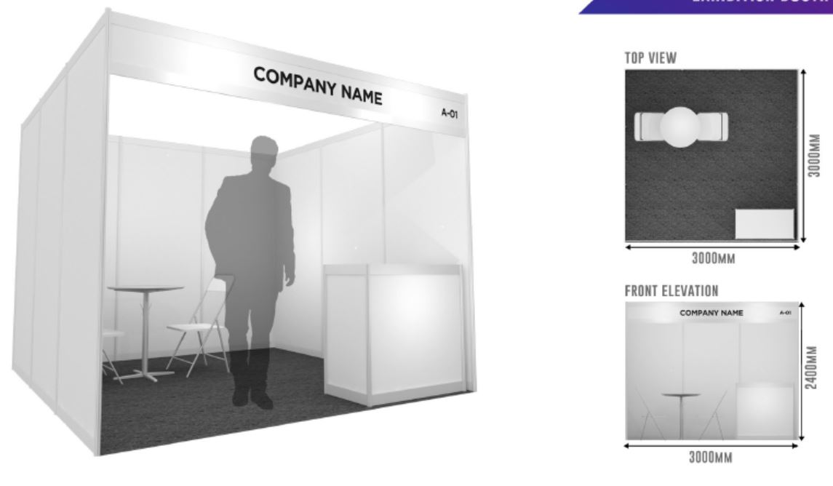

**3-2. Contractor & Height Restriction**

Exhibitor Appointed Contractor (Non-Official Contractor)

* Special Design Booth

※Exhibitors with a special design booth must complete and submit the Form 1 with designated floor

planning and drawing.

※Before any construction, a contractor must cover the floor with a suitable material and to use only

an easy-to-clean tape specifically to avoid any damage to the exhibition hall.

※It is prohibited to use any wire to secure booth structures to the floor or walls of the exhibition hall.

* Modifications

※Exhibitors are required to notify the Organizer for any modifications after submitting the booth plan.

Height Restrictions

For Shell-Scheme Booths –maximum of 2.4m in height

* For Raw-Scheme Booths:

※The permitted stand & decoration height not over **4m in height**

※Any design for a structure exceeding 4m in height must be submitted for approval at least 2 weeks prior.

**3-3. Electrical**

Electrical Requirements

The official electrical contractor for ATPS 2022 is Knoxx Pte Ltd and all electrics must be ordered through them using the appropriate form. For safety and liability reasons the installation of electrical power onto stands at ATPS 2022 may only be undertaken by Knoxx Pte Ltd, the official electrical Contractor, who will ensure that all connections are verified as safe before being energized. The electrical facilities in the Hall are subject to Regulations of Kuala Lumpur Convention Centre.

We recommend that Space Only contractors do contact Knoxx Pte Ltd as soon as possible with any electrical requirements for the show.

Exhibitors/ Contractors are not permitted to carry out work on the venue’s electrical installation without written permission from the venue.

The Organizer reserves the right to remove or disconnect any electrical equipment which appears defective or has inadequate evidence of electrical inspection.

Please ensure you order a sufficient number of sockets to prevent overloading.

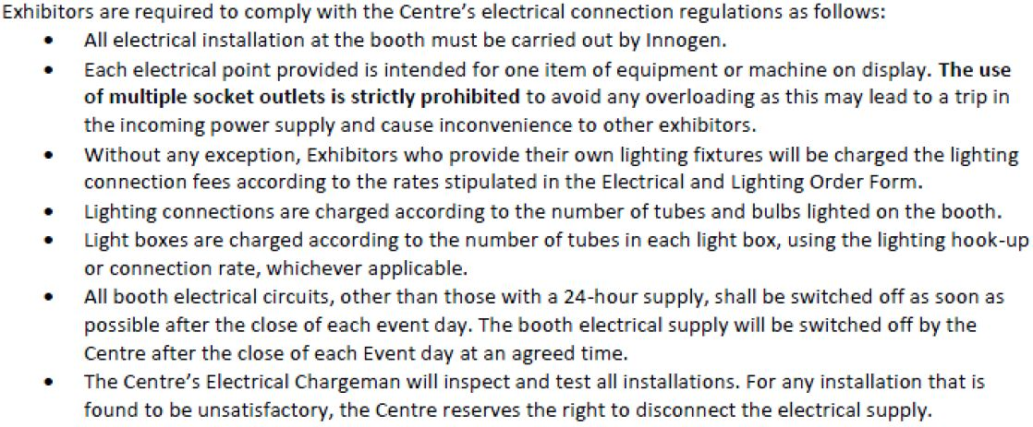

* 1. **Non Official Contractor Form**

|  |  |
| --- | --- |
| **SPECIAL DESIGN OF RAW SPACE ONLY** | **FORM 1** |
| Please complete and return the form to  **KNOXX PTE LTD**  51 Tai Seng Avenue, B1-03, Pixel Red, 533941  Attention: Mr Raymond Sim, Tel: (65) 6904 2498; Fax: (65) 6904 2484    Email: rs@knoxx.com.sg | **Deadline:**  22nd April 2022 |

NO P.O. BOX ADDRESS PLEASE STAND NO:

|  |
| --- |
| Company Name: |
| Address: |
|  |
| Postal Code: Country: |
| Contact Person: Job Title: |
| Tel: Fax: |
| E-mail: Signature: |

This form is applicable to exhibitors who have contracted for SPACE ONLY and will be engaging their own stand fitting contractor or are building their own stands.

All approved contractors, other than the Official Contractors, must place a refundable Performance Bond of **USD$ 50.00/sqm(Refundable)** and Administrative Fee of **USD$ 35.00/sqm(non-refundable).** Cheques should be made out in favor of “**KNOXX PTE LTD**”

This is to ensure that the rules & regulations are abided by and to cover any damages arising directly or indirectly from any infringement. This is without prejudice to any additional claim the Organizer may have on the contractor and/or exhibitor if the damages exceed the deposit.

|  |
| --- |
| **This form must be jointly signed by the exhibitor and the appointed stand fitting contractor, together with the Performance Bond fill up & email or fax back to KNOXX PTE LTD.** |

Stand-fitting Contractor : _______________________________________________________________________

Address: _________________________________________________________Country:____________________

Tel: _____________________ Fax: _____________________ E-mail: ___________________________________

Person in charge: ____________________________________ Mobile Phone:_____________________________

Signature: _____________________________________________________ Date: ________________________

**PLEASE NOTE**

1. Soft copies of **TECHNICAL DRAWINGS** (plan & perspective view) of your stand design MUST BE SUBMITTED to the Organizer for approval by **29 April 2022,** OR **IMMEDIATELY**, if you join the Exhibition after the above stipulated deadline. Please refer to rules & regulations in this manual for more information.
2. ALL electrical connections must be done by the Official Stand Contractor.
3. Stand height should **not exceed 4m** due to venue ceiling height. Written approval must be obtained from the Organizer on any special design stands.

**Performance Bond Form**

**Refer to overleaf**

* 1. **Performance Bond Approval Form**

**SPECIAL DESIGN OF RAW SPACE ONLY (COMPULSORY)**

**PERFORMANCE BOND & ADMINISTRATIVE FEE FORM**

Date : _____________________________

Company : _____________________________

Tel : _____________________________

Fax : _____________________________

Exhibitor : _____________________________

Booth number : _____________________________

Attention : _____________________________

Mobile : _____________________________

Email : _____________________________

Dimension : ____________ m X ___________ m

Total Booth Area : ___________________________ sqm

**Important Notes:**

1. All works must be carried out in a safe manner and comply with all local authority requirements, including, but not limited to the “Workplace Safety & Health Act”.
2. Stand should be constructed strictly in accordance to the drawings submitted. The Stand should be re-enforced to ensure the structure stability if any fixtures and/or equipment are loaded.
3. The appropriate insurance coverage must be arranged and the certificate must be ready for on-site inspection.
4. Material samples and certifications used in Stand construction must be ready for on-site inspection by the Fire Safety & Shelter Department (FSSD).
5. Stand design for covered ceiling must be submitted to the local authority, Fire Safety & Shelter Department (FSSD) for their approval.
6. During the build-up and dismantling periods, exhibitors and/or appointed contractors are responsible for the removal of stand construction debris and rubbish on a daily basis. All aisles must be left clear. Exhibitors are reminded that it is their responsibilities of their appointed stand fitting contractor to clean and removed stand construction debris / rubbish from the exhibition site daily. Any debris or rubbish left behind will be removed by the organizer and the cost will be charge to you.
7. Exhibitors must arrange for their cartons and cases to be transported back to their own premises. Exhibitors are not to store such items within the exhibition halls. The Organizer reserves the right to remove/dispose of any carton, cases and/or packing materials left in the exhibition halls. Any cost incurred will be borne by the exhibitor.
8. No smoking is allowed in the halls. The contractor will be penalized if any of their staff are found smoking in these prohibited areas.
9. Paint brushes must be washed at the washing bay only and not in the toilets. Exhibitors are reminded that it is the responsibility of their appointed stand fitting contractor to clean and removed paint on the floor. Any such damage to the exhibition floor will be invoiced to the Exhibitor.

**All amount is in US Dollars:**

Performance Bond : USD$ 50 per sqm Total Payable : USD$ ___________________

Administrative Fee : USD$ 35 per sqm Total Payable : USD$ ___________________

**Acknowledgement:**

I,_________________________________________ on behalf of ______________________________________

Hereby agreed to guarantee production schedule, conduct, any damages caused and our observance of the exhibition rules & regulations.

**Signature :** _______________________________

**Date :** _______________________________

**Company's Stamp :** __________________________

* 1. **Other Technical Service**

Lighting Supplies

* Lighting

※ Lighting connections are charged according to the number of per Light Tube, bulb and LED fitting fitted on the stand.

※ Light boxes are charged according to the number of tubes in each light box, using LED strips per meter run or the lighting connection or 40W fluorescent tube rate, whichever is applicable

※ For additional lighting supplies (spotlights, fluorescent tubes, etc), fill out the Form 4

※ For positioning, fill out the Form 4B

* Power socket

※ Power points are meant for running of equipment/exhibits only.

※ If used for lighting purposes, the lighting connection charges will apply on per light bulb/per light tube basis.

*\*\* Non-compliance of the electrical regulations resulting in power disruption will cause a penalty charge to be levied to the exhibitor or the appointed Special Design Stand Contractor.*

* 1. **Construction Policies**

Safety

* Booth structure and all other materials used within the booth must maintain safety at all times.
* Exhibitors are asked to check the stability and strength of all showcases, counters and any other furniture used during the show days.
* Avoid any obstructions or interfering structure for evacuation when designing booth.

*\*\* In the case where the Organizer and/or Kuala Lumpur finds that the building of stand is not safe or may cause any damage, Organizer reserves the right to stop the construction work immediately and amendment must be made.*

Booth Design

* Exhibitors must be aware to take in all attendees within the booth boundary for all promotional activities and events. Maintain sound level to avoid trouble with immediate neighbors.
* Stage and TV monitors shall not be built or displayed adjacent to the aisles.
* All booth shall be pleasantly designed for attendees. The Organizer would ask all exhibitors to consciously plan a barrier-free design.

Fire Protection

* All materials used inside the exhibition hall must be fire-resistant.
* All flammable work is strictly prohibited inside the venue.

Booth Cleanliness

* The Organizer will be in charge of the general cleaning before and after the show. Each exhibitor is asked to clean or vacuum the booth, as well as responsible for all debris and garbage on a daily basis.
* It is the Exhibitor’s sole responsibility to ensure that their stand remains clean throughout the build-up and open days of the exhibition. During the build-up and dismantling exhibitors are requested to remove of all their own rubbish.
* Exhibitors with special design booth are required to recover the space after the show.

Prohibitions

* No direct anchor bolting on the venue floor.
* No canopies or ceiling booth structure.
* No direct construction to the venue facilities or booth structure such as: screwing, nailing, cutting, curving, welding, drilling, painting, pasting, bonding and any other form of activities that may cause damage to the venue or booth structure.

**Rules & Regulation**

**4-1. Basic Rules**

**Admission**

All exhibitors must put on their exhibitors’ badges at all times for access to the exhibition venue.

**Promotions during the Show**

Exhibitors are asked not to place stickers, signs or posters anywhere in the halls other than within their own stand and on paid advertising poster sites and billboards. Likewise, exhibitor’s representatives may not distribute brochures, invitations, etc. at the registration areas, Exhibition Hall Entrance / Exit, F&B outlets, show hospitality areas, or any other areas which, in the opinion of the Organizer, is deemed inappropriate and causes inconvenience to visitors and other exhibitors.

**Product Demo & Presentations**

The Organizer appreciates that demonstrations and presentations form an integral part of the exhibition. Exhibitors, however, should exercise discretion when carrying out demonstrations and presentations, in consideration of other exhibitors.

Loudspeakers/sound devices and/or image projection equipment are to be placed in such a way that sound/image is directed downwards and into the stand, and NOT towards or across the aisles. The operation of any sound device or image projector must not interfere with, or be an annoyance to neighboring stands. Sound level recorded at adjacent or opposite stands should not exceed 70dB for all speech, music and sound effects.

The Organizer may also require such demonstrations or presentations to be carried out in accordance to a timetable as laid down after the consultations with the exhibitors involved.

Exhibitors planning to stage demonstrations or presentations must provide a reasonable space for the audience within the confines of the stand.

**Animals**

Unless otherwise stated, animals are not allowed to be used as a stand attraction, for performance or demonstration purposes at the exhibition.

**Electrical Connections**

1. For safety reasons and for the protection of the electrical installations at the Centre, all main power connections from source to outlet during events must be carried out by the Centre’s appointed suppliers.

2. Event Organiser must ensure that their nominated electrical contractors are registered with the Suruhanjaya Tenaga (Energy Commission) and comply with Centre’s Electrical Policy as stated below, including but not limited to:

a) Event Organiser must ensure that the distribution board and associated wiring is equipped with Residual Current Devises and circuit breakers of the appropriate rating

b) All provisions and appliances used within the Centre have been tested and tagged as safe in accordance with the relevant safety and health regulations and comply with MS IEC 60364 and IEE Regulations

c) The Event Organiser must ensure that the appointed Contractor must use the correct commando plug for connecting to power supply

d) For approved direct connection a cable lug must be used

e) Services / Connections do not cross aisles, block exits or interfere with the operation of emergency exits or firefighting equipment

f) Each electrical point provided is intended for one item of equipment or machine on display. The use of multiple socket outlets is strictly prohibited to avoid any overloading as this may lead to a trip in the incoming power supply and cause inconvenience to others.

g) Access to the floor trenches is limited to employees of the Centre, and the Centre’s appointed suppliers who install the main supply cables, piped services and data and telecommunication services.

h) Where possible cables should be raised above the walkway. If this is not possible, cables need to be covered with cable ramps failing which carpet tiles, matting or gaffer tape should be used to ensure exposed cables are covered.

i) In high traffic areas changes in floor levels should be highlighted with high visibility yellow/black hazard tape.

3. The Centre reserves the right to disconnect the electrical supply to any installation which, in the opinion of the Centre’s Electrical Chargeman, is dangerous or likely to cause annoyance to visitors or other exhibitors.

4. Charges for power connections are applied for all events and is are to be installed by the appointed official event contractor.

**Floor Loading Capacity**

30KN/sqm (625 lbs/sq ft) of concrete flooring.

The permitted floor loadings stipulated by the venue owners must not be exceeded. However, on a case-by-case basis, subject to the approval of the venue owner, special arrangements including the provision of steel base plates may be required for any exhibit exceeding these limits. The Organizer’s delivery schedule for heavy and large exhibits must be strictly adhered to.

**Dangerous Materials**

1. No temporary gas (LPG) or naked live electrical fittings are to be used in the exhibition halls at any time.
2. No explosives, petrol, dangerous gases or highly inflammable substances are allowed in the halls.
3. No radioactive substances are allowed unless prior approval in writing is obtained from the Organizer. Any radioactive substances being used must strictly comply with the rules and regulations stipulated by the relevant regulatory body.

**Structural Height Restriction**

The permitted stand height is 2.44m (8ft). Any design for a structure exceeding 2.44m in height must be submitted for approval at least 4 weeks prior to the exhibition and will be considered on a case-to case basis, to a maximum height of 4m (subject to approval with the relevant professional endorsements to prove that the structure is structurally safe). If approved, this structure will be restricted to a distance of 1 meter (3.28 ft) away from the dividing walls of the adjoining stands. *This restriction also applies to any overhead structure suspended from the existing hall ceiling.*

**Stand Boundaries and Design Restriction**

All stands must be carpeted or laid with some form of flooring as clear demarcation of contracted space. Except for “island” booths (4-side open), a back wall must be installed for every stand. Stand with immediate neighbor(s) should also be provided with the necessary sidewall(s).

Exhibitors may not place any display material or exhibit, nor extend their stand structures and fittings, beyond their contracted boundary. The exhibitor will be charged for any infringement of this rule, and the Organizer reserves the right to remove the infringement. *Likewise, any display of programmable moving lights (cyber lights) is restricted within the perimeter of their stand. The prevailing rate for space rental on per square meter basis will be charged to exhibitors who fail to comply with the above.*

**Open Frontage**

All stands in the exhibition, irrespective of height, must have **at least 50% of any frontage** facing an aisle left open or fitted with transparent (clear see-through) material. This area must be left visibly free of obstruction.

**Building Material**

Materials for the construction of the exhibition booths shall have a minimum flame spread rating of Class 2.

**Damage to Stand Structures and Exhibition Premises**

No person under any circumstances shall cut into or through any floor covering or wall nor alter the stand service structure except when authorized in writing by the Organizer. Any such damage to the stand service structures will be invoiced to the Exhibitor.

No screwing, drilling, painting or nailing on any of the aluminum frames and existing system pifex panel. In default whereof, the exhibitors or their appointed contractors shall be liable for the total loss resulting therefore and **USD$ 150.00** will be charged for the damage of each aluminum frame or panel.

**Official Contractors**

1. The Organizer has appointed Official Contractors for various services so as to ensure a more efficient and regulated build-up and dismantling. Please refer to the Useful Contact List for details (Page 7-8). Unless otherwise stated, exhibitors may appoint their own stand fitting contractor subject to approval from the Organizer. In this instance, exhibitors are responsible for making their own arrangement for services.
2. The services of the Official Contractors are for the convenience of exhibitors, and the Organizer will accept no liability in respect of any contract between exhibitors and such contractors for the negligence or default of any such persons, their servants and agents.

**Storage**

Exhibitors must arrange for their cartons boxes, wooden pallets and wooden cases to be transported back to their own premises. Exhibitors are not allowed to store such items within the Venue. The Organizer reserves the right to remove/dispose of any cartons boxes, wooden pallets and wooden cases and/or packing materials left in the exhibition halls. Any cost incurred will be borne by the exhibitor and a handling fee of **USD$ 500 per booth** will be charge to the exhibitor.

**Stand Fitting Contractor**

In adherence to safety requirements, only Kuala Lumpur Convention Centre can carry out **water pipe and hanging/rigging installations.**

Exhibitors may appoint their own contractor for stand design and construction subject to them being approved by the Organizer.

All approved contractors must lodge a **refundable deposit of USD 50 per sqm.** This serves as a performance bond as well as a damage deposit. This deposit will be refunded after deduction for services and damages, if any. Exhibitors are responsible and liable for their appointed contractor’s observance of all rules and regulations.

There is also an **administrative fee(non-refundable) of USD 35 per sqm.**

**Contractor Badge Entitlement (Additional badge is chargeable at USD$5 each)**

**This is not the event exhibitor required badge.**

|  |  |
| --- | --- |
| **Space Occupied** | **Contractor Badge Entitlement** |
| 9 to 17 sqm | 8 badges |
| 18 to 35 sqm | 12 badges |
| 36 and above sqm | 15 badges (maximum) |

**Cleaning & Event Waste**

1. Additional cleaning charges apply to Exhibitor in the following instances:

a) Removal of paints, grease, oil, stubborn tape and/or stains

b) Disposal and/or cleaning of waste generated by exhibitors due to booth activities

c) Removal of all accumulated rubbish and/or exhibits that are left at the loading bay

d) Waste Removal is charged on a per skip basis and this includes the use of bulk bins and the subsequent disposal and recycling of waste.

**Booth Cleaning**

Booth cleaning is not provided in the Venue Hire for Event Organisers. Exhibitors who require any booth cleaning service shall place their order through the [Exhibitor Service Centre.](https://www.klccconventioncentre.com/plan/exhibitor-service-centre-bk)

**Event Waste**

The Centre does not provide dedicated waste disposal or recycling facilities for event waste. At the end of the event, the hirer, exhibitors and contractors must ensure all equipment has been removed prior to the end of the hiring period. Abandoned equipment and/or excess waste will be removed by the Centre at a cost to the Event Organiser.

Exhibitors are reminded that it is their responsibilities to clean and removed stand construction debris / rubbish / carton boxes / wooden pallets from the exhibition site, especially after event. Any debris / rubbish / carton boxes / wooden pallets left behind will be removed by the organizer and a handling fee of **USD$ 500 per booth** will be charge to the exhibitor.

**Regulatory Authorities**

Where applicable, the above rules and regulations are additional to rules and directions set by the Regulatory Authority. All exhibitors and their contractors must abide by the code of practices set by the relevant regulatory authorities.

**Security**

1. The Centre maintains twenty-four (24) hour general security for the building perimeter areas together with the provision of internal patrols. The Centre’s control room is manned twenty-four (24) hours a day, seven days a week. The primary function of the Centre’s control room is to monitor security and offer surveillance the Centre.

2. The Centre has overall control of all security systems and security procedures necessary to ensure the safety of all persons in the Centre at all times.

3. The Centre is entitled to employ or engage security personnel or special duty police as it sees fit in order to ensure security is maintained. If this requirement is event related, costs for extra security personnel will be borne by the Hirer and/or Event Organiser.

1. If required by special circumstances, the Event Organiser may engage licensed and authorised independent and/or armed security for any event to provide escort, crowd management services and/or security for any cash or valuables from or in the event space.

5. Event Organiser must provide the following information of the hired external and armed security to the Centre’s Coordinator at least fourteen (14) days before the hiring period:

a) Letter of appointment of the security company by the Event Organiser

b) Profile of the external security company

1. The Centre is the exclusive provider of security control.
2. Security charges apply to all events, whether stand-alone or as part of an event.

9. Security staffing levels will be determined by the Centre’s Coordinator based on the size and nature of the event.

**Exhibitor Badge Entitlement**

Badges can be collected at the Registration Counter at Level 4 Hall 8A, from 22th May 2022, starting at 1630 hrs onwards**.**

Please note that exhibitors **are not required to requisite for Contractor badges** as the Exhibitor badges are valid for entry into the exhibition hall throughout the entire show duration, including build-up & tear-down days.

**B22 Forbidden items**

Helium Balloons, Branding Stickers are strictly forbidden in Kuala Lumper Convention Centre. The Organizer reserves the right to ask the Exhibitors to stop distributing the items. Any cost incurred will be borne by the exhibitor.

**B23 Advertising Canvassing, Solicitation and Distribution**

* + 1. Distribution or placement of pamphlets, brochures or other marketing material in public areas and under car windscreen wipers or door handles on vehicles parked at the Centre’s car park is prohibited.
    2. Without any prior approval, no exhibits, displays or advertising materials of any kind will be allowed in the Centre’s public areas, basement parking or hallways.
    3. All display/content exhibits or advertising materials must be truthful and non-misleading, and contents that are political or religious in nature or that in the opinion of the Centre are offensive to local norms are prohibited.
    4. The Centre’s prior approval must be obtained for the display of any display/content exhibits or advertising materials of any kind at the Centre’s public areas, basement parking area or hallways.

5. Please refer to the [Banner, Advertising and Event Signage (download)](https://www.klccconventioncentre.com/clients/asset_1D27A8C6-DE8C-4066-B3D8-0593D73C0267/contentms/img/pdf/permits/form-banner-advertising-and-event-signage.pdf) for advertising opportunities at the Centre

* 1. **Do & Don’t for Exhibitors**

**Do’s and Don’ts for Exhibitors**

**Rules & Regulations**

All items entitled in the Standard booth package are not interchangeable. Exhibitors may opt for all or part of the items listed. Pictures shown are only artist’s impressions. Exact number of sidewalls and furniture will depend on each individual location and/or exhibitor’s own indicated preferences.

**Damage to Stand Structures and Exhibition Premises**

* No nailing or use of glue onto the System Panel is allowed. ONLY removable tape is allowed.
* For hanging of heavy material, please contact the appointed contractor for arrangement. Exhibitors will be liable for all costs involved to restore damages.



**Important Note:**

* Exhibitors are not allowed to paint or wall papering of the stand.
* Exhibitors are not allowed to nail, drill or screw holes into the panel walls. Brackets have to be supplied by the exhibitor and are to carry the exhibitor’s display panel, signs, etc. from top of the panel wall. The hanging/installation of item is to be carried out by the Exhibitor.
* Any damage caused to the Exhibitor’s stand by the exhibitor or his representative or staff will be invoiced to the Exhibitor.
* Exhibitors who have their own poster and wish to install the poster by themselves are required to use the tape as advised below:

  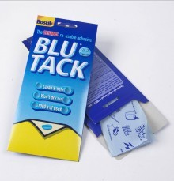

**BLU TACK**

**DOUBLE SIDED TAPE**

**VELCRO TAPE**

* During the build-up and dismantling periods, exhibitors and/or appointed contractors are responsible for the removal of stand construction debris and rubbish on a daily basis. All aisles must be left clear. Exhibitors are reminded that it is the responsibilities of their appointed stand fitting contractor to clean and removed stand construction debris / rubbish from the exhibition site daily. Any debris, graphics sticker/ foam board or rubbish left behind will be removed by the organizer and the cost of **USD$150.00** will be charged to you.
  1. **Product Sampling & Sales**

Product Sampling

* Forbidden Items

※ Helium balloons and any other items that are difficult to remove from the venue space/Any items that may cause damage to the venue/Pointed and sharp objects that may cause injuries.

※ Product sampling must be conducted within the booth boundary. Avoid distributing items that may overload the capacity of the booth.

* Food Sampling

※ Sampling of food must be noticed to the Organizer in advance.

※ The Organizer will review the request and report to the exhibitor accordingly.

※ Requests may be rejected due to the venue restrictions or law.

Product Sales

* Rules & Regulations

※ Products to be sold during the show days all must be officially licensed. No bootlegs are allowed for product sales.

※ Exhibitors who sell products must discuss and fix the sales plan with related companies and associates (licensees, productions, distributors, etc.) prior to the actual selling at the venue booth.

※ The Organizer has the right to discontinue the product sales of all exhibitors if any problems are reported from related companies and associates.

* Forbidden Items

※ All sales products must meet the public policy.

※ Pornography and any other products that depict obscenity are all prohibited for selling.

※ The Organizer reserves the right to abandon any product sales that are unsuitable to be sold during the show days.

* Sales Policies

※ Exhibitors are asked for a smooth operation of product sales during the show days.

※ Problems and claims regarding product sales are sole responsibility of exhibitors.

※ All exhibitors are responsible for their own total sales, cash and management of product sales.

※ Change is not available at the Organizer Room.

* 1. **Cautions**

Prohibited Acts

* The Organizer strictly prohibits the acts below.

【Prohibitions】

・Harassment

・Gambling

・Pornography

・Alcohol & Smoking

Cooking & Hot Work Demonstrations

* Cooking & Hot Work Demonstrations

・No naked or open-flame equipment is to be used in the exhibition hall at any time.

・Only electrical appliances are allowed and which had been approved by the Organizer.

・Use of Liquid Petroleum Gas (LPG) in the service area is strictly prohibited.

* 1. **Emergency Cases**

Covid-19 & Sickness/Injuries

* Immediately report the Organizer.
* The Organizer is not fully responsible for all attendees or exhibitors with sickness or injuries.
* Do not come to the venue/event if you are not feeling well.

**Covid-19 Venue Check- n Protocols**

* Effective from 1 October, 2021, it will be compulsory for visitors attending events and/or dining at the food outlets to provide a valid certificate of vaccination to prove full vaccination which shall mean 14 days after the 2nd dose in a 2 dose series, such as Cormirnaty (Pfizer-BioNTech), Covid-19 AstraZenaca (Oxford-AstraZenaca), CoronaVac (Sinovac), Spikevax (Moderna) and Covilo (Sinopharm) or 28 days after a single dose vaccine, such as COVID-19 Janssen (Johnson & Johnson) and Convidecia (Can Sino).
* Show proof of digital vaccination certificate in MySejahtera or vaccination card for those who are encountering issue with the update of their vaccination status in their MySejahtera
* Show COVID-19 Risk Status in MySejahtera
* Undertake body temperature check
* Check-in by scanning QR code or manually by those without smartphones.
* Adhere to physical distancing of at least 1 metre apart
* Use hand sanitisers prior to entering
* Wear face masks in government mandated manner

**Deny Entry to Venue**

* They are not able to show proof of digital vaccination certificate in MySejahtera or a vaccination card.
* They fail or refuse to wear mask properly, undergo body temperature check or undertake the COVID-19 Health Protocols.
* Their body temperature is above 37.5 Celsius.
* They exhibit any symptoms.
* Their COVID-19 Risk Status in MySejahtera is other than “Low Risk” and “Casual Contact Low Risk” status.
* Event Attendees who are exempted from vaccination will only be allowed entry if they can provide medical certificate that exempts them from vaccination on medical grounds.
* Event Attendees who are below the age of 18 will only be allowed entry if they are accompanied by a fully vaccinated person.

Booth Problems

* All exhibitors are required to solve problems occurred within the booth and submit a report to the Organizer.
* Booth operation problem is sole responsibility of exhibitor.
* Exhibitors may report sound, crowd and any other problems that distract the booth operation to the Organizer. The Organizer will be in charge and handle the problems.
* Exhibitors are to be responsible for the safety of their own/personal belongings. Organizers are not held responsible for any loss of items.
  1. **Cancellation & Postponement**

Show Cancellation

* The Organizer will cancel or postpone the ATPS 2022 in case of; social conditions, natural calamity, venue accidents, terrorism or any other conditions that disables the opening of the event.
* The Organizer will not be in charge for the loss and damage created by the show cancellation under the conditions stated above.

Rule Modification

* The Organizer will modify and change the rules and regulations in exhibitor manual in case of unavoidable situation. When such alternation has taken place, the Organizer will immediately report all changes to the exhibitors.

Safety

* The Organizer is in full charge for the preservation of the event venue during all show days, including construction and dismantle days. All exhibitors are responsible for any product theft/damage, loss accidents, human injuries and fire incidents during the show days.
* The Organizer highly recommend all exhibitors to take out insurance in advance.

Violation Charge

* The Organizer reserves the right to cancel the exhibition or ask for the improvement when any form of violation towards the exhibitor manual has reported. All damages caused by any violation will be a responsibility of the exhibitor.

**Exhibitors Service**

**5-1. Check List for Order Forms**

**TECHINCAL SERVICES FORM CHECK LIST**

|  |  |  |  |  |
| --- | --- | --- | --- | --- |
| **FORM** | **SERVICES** | **PAGE NO.** | **Status** | **SUBMISSION DEADLINE** |
| 1 | Special Design of Raw Space /  Upgrading of Shell scheme stands | 11 |  | 22th April 2022 |
| Performance Bond Form | 12 |  |
| 2 | Fascia Name - Shell Scheme Package | 22 |  | 29th April 2022 |
| 3 | Furniture | 23 - 24 |  | 29th April 2022 |
| 4 | Electrical Supplies & Fittings Rental | 25 |  | 29th April 2022 |
| 4B | Electrical & Lighting Service Location Plan | 26 |  | 29th April 2022 |
| 5 | Graphic Print | 28 |  | 29th April 2022 |
| **ALL FORMS TO BE RETURNED TO:**  **KNOXX PTE LTD**  51 Tai Seng Avenue, B1-03, Pixel Red, 533941  Attention: Mr Raymond Sim, Tel: (65) 6904 2498; Fax: (65) 6904 2484  Email: rs@knoxx.com.sg | | | | |

The terms and conditions of contract / rules & regulations should be read together with the Publicity and Technical Service Manual, which form part of your contract to exhibit.

Please use this checklist of forms to help you plan your work schedule and participation.

**All** forms (regardless whether the service is required or not) must be returned by the exhibitors by the deadlines stated on the form. Services cannot be guaranteed for forms that are submitted after the stipulated deadline.

**A 50% surcharge applies for orders accepted after the deadline.**

**Exhibitors who contract for space after the deadline are to return ALL forms immediately.**

When in doubt, please contact **KNOXX PTE LTD**

|  |  |
| --- | --- |
| **FASCIA NAME – SHELL SCHEME PACKAGE** | **FORM 2** |
| Please complete and return the form to  **KNOXX PTE LTD**  51 Tai Seng Avenue, B1-03, Pixel Red, 533941  Attention: Mr Raymond Sim, Tel: (65) 6904 2498; Fax: (65) 6904 2484    Email: rs@knoxx.com.sg | **Deadline:**  29th April 2022 |

NO P.O. BOX ADDRESS PLEASE STAND NO:

|  |
| --- |
| Company Name: |
| Address: |
|  |
| Postal Code: Country: |
| Contact Person: Job Title: |
| Tel: Fax: |
| E-mail: Signature: |

Please indicate on the table below the name of the exhibiting company and stand number to be reflected on the fascia board*. This will be provided in upper case, standard 100mm-high (4 inches) English alphabet (maximum 30 letters). PLEASE USE BLOCK LETTERS.

COMPANY NAME STAND NO

* Maximum 30 letters

|  |  |
| --- | --- |
| **FURNITURE** | **FORM 3** |
| Please complete and return the form to  **KNOXX PTE LTD**  51 Tai Seng Avenue, B1-03, Pixel Red, 533941  Attention: Mr Raymond Sim, Tel: (65) 6904 2498; Fax: (65) 6904 2484    Email: rs@knoxx.com.sg | **Deadline:**  29th April 2022 |

NO P.O. BOX ADDRESS PLEASE STAND NO:

|  |
| --- |
| Company Name: |
| Address: |
|  |
| Postal Code: Country: |
| Contact Person: Job Title: |
| Tel: Fax: |
| E-mail: Signature: |

|  |  |  |  |  |
| --- | --- | --- | --- | --- |
| **Code** | **Item** | **Unit Cost (USD$)** | **Quantity** | **Amount (S$)** |
|  | Information Counter (760mmHt) | 50.00 |  |  |
|  | Lockable Cupboard (760mmHt) | 65.00 |  |  |
|  | High Showcase (1m x0.5m x 2mHt) | 280.00 |  |  |
|  | Square High Showcase (0.5m x 0.5m x 2mHt) | 220.00 |  |  |
|  | Low Showcase (1m x 0.5mx 1mHt) | 130.00 |  |  |
|  | High Display Cube (1030mm Ht) | 70.00 |  |  |
|  | Low Display Cube (500mm Ht) | 50.00 |  |  |
|  | Shelf-Flat per metre run (slope/flat) | 30.00 |  |  |
|  | 4ft x 2ft Table c/w skirting | 55.00 |  |  |
|  | Round table with wooden top (white) | 45.00 |  |  |
|  | Bistro Table | 50.00 |  |  |
|  | Folding Chair | 12.00 |  |  |
|  | Free Standing Brochure Rack | 50.00 |  |  |
|  | Bar Stool | 50.00 |  |  |
|  | Wastepaper Basket | 5.00 |  |  |
|  | Bar Refrigerator c/w 13Amp Power Point | 180.00 |  |  |
| **Note:** | 1. **Lighting for showcase to be ordered separately in form 3** | |  |  |
|  | 1. **Late orders are subjected to stock availability.** | | **Subtotal** | **USD$** |
|  | 1. **A 50% surcharge applies for orders accepted after the deadline.** | | **Grand Total** | **USD$** |

|  |  |
| --- | --- |
|  |  |

**Furniture Catalogue**

**Refer to overleaf**

**Furniture Catalogue**

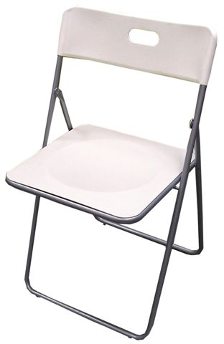

**FOLDING CHAIR**

**ARM CHAIR**

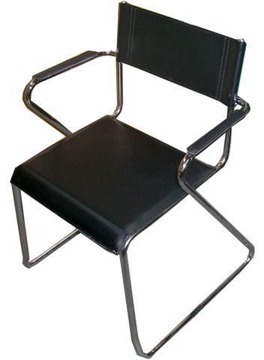

**BAR STOOL**

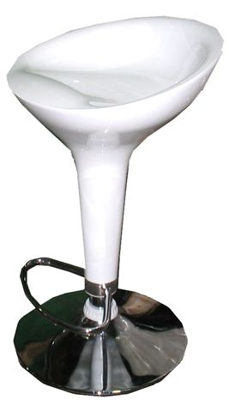

**SQUARE TABLE**

**BAR TABLE**

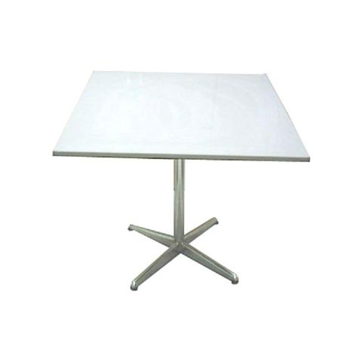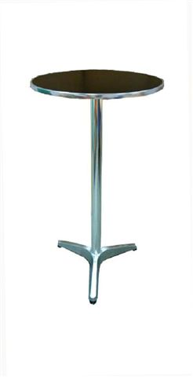

**HIGH SHOWCASE**

**SQUARE SHOWCASE**

**LOW SHOWCASE**

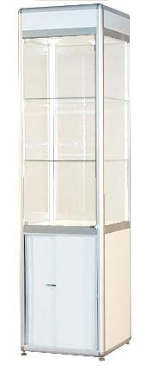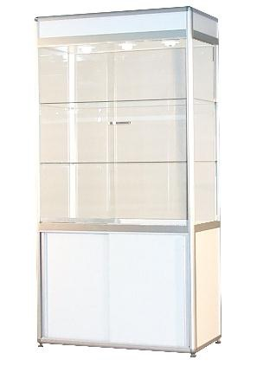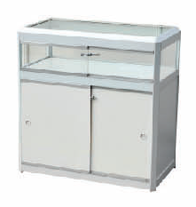

**INFO COUNTER**

**LOCKABLE COUNTER**

**DISPLAY CUDE**

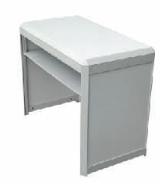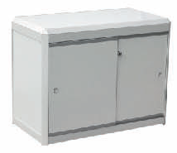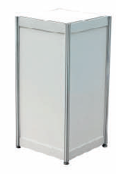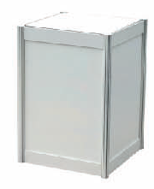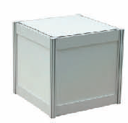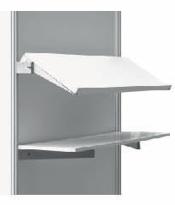

**SHELF**

**BROCHURE RACK**

**BAR REFRIGERATOR**

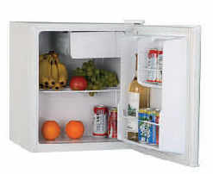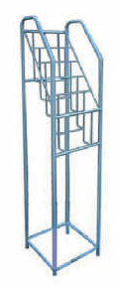

**ROUND TABLE**

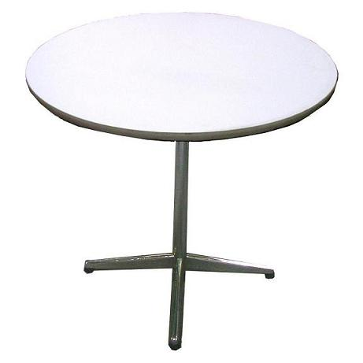

**COAT HANGER**

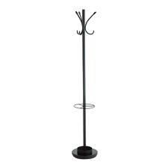

|  |  |
| --- | --- |
| **ELECTRICAL SUPPLIES & FITTINGS RENTAL** | **FORM 4** |
| Please complete and return the form to  **KNOXX PTE LTD**  51 Tai Seng Avenue, B1-03, Pixel Red, 533941  Attention: Mr Raymond Sim, Tel: (65) 6904 2498; Fax: (65) 6904 2484    Email: rs@knoxx.com.sg | **Deadline:**  29th April 2022 |

NO P.O. BOX ADDRESS PLEASE STAND NO:

|  |
| --- |
| Company Name: |
| Address: |
|  |
| Postal Code: Country: |
| Contact Person: Job Title: |
| Tel: Fax: |
| E-mail: Signature: |

|  |  |  |  |  |
| --- | --- | --- | --- | --- |
| **Item** | | **Unit Cost (USD$)** | **Quantity** | **Amount (USD$)** |
| Fluorescent Tube 40w | | 30.00 |  |  |
| Spotlight 100w | | 85.00 |  |  |
| Long-arm Spotlight | | 95.00 |  |  |
| 70W HQI Light | | 100.00 |  |  |
| 150W HQI Light | | 160.00 |  |  |
| 300W Flood Light | | 120.00 |  |  |
| 50W Halogen Down light | | 46.00 |  |  |
| 100W Lighting Connection per fitting | | 35.00 |  |  |
| 300W Lighting Connection per fitting | | 70.00 |  |  |
| 13amp. Power Point/230V (Sufficient for 5amp fuse) | | 42.00 |  |  |
| 13amp. Power Point/230V (Sufficient for 5amp fuse) 24hrs | | 100.00 |  |  |
| 15amp. Power Point/230V | | 72.00 |  |  |
| 15amp Three Phase Isolator (Machine/equipment use only) | | 130.00 |  |  |
| 30amp Three Phase Isolator (Machine/equipment use only) | | 180.00 |  |  |
| 60amp Three Phase Isolator (Machine/equipment use only) | | 320.00 |  |  |
| Note: | 1. Power points are meant for running of equipment/exhibits  only. If used for lighting purposes, the lighting connection  charges will apply on per bulb/per tube basis.  2. Lighting connections are charged according to the number of  Tubes, bulbs and LED fitting fitted on the stand.  3. Light boxes are charged according to the number of tubes in  each light box, using LED strips per meter run or the lighting connection or 40W fluorescent tube rate, whichever is applicable.  4. Late orders are subjected to stock availability. | | **Subtotal** | **USD$** |
|  | **5. A 50% surcharge applies for orders accepted after the deadline.** | | **Grand Total** | **USD$** |

|  |  |
| --- | --- |
|  |  |

**Continue on to Form 4B**

**Refer to overleaf**

|  |  |
| --- | --- |
| **ELECTRICAL & LIGHTING SERVICE LOCATION PLAN** | **FORM 4B** |
| Please complete and return the form to  **KNOXX PTE LTD**  51 Tai Seng Avenue, B1-03, Pixel Red, 533941  Attention: Mr Raymond Sim, Tel: (65) 6904 2498; Fax: (65) 6904 2484    Email: rs@knoxx.com.sg | **Deadline:**  29th April 2022 |

* This form must be submitted together with the electrical and lighting order form to the Official Contractor.
* Sketch the location of your utilities, such as power outlets and light fittings
* Location of your electrical requirements will be installed at the discretion of the Official Stand-fitting Contractor if the layout plan is submitted after the deadline. Any relocation after installation will be **charged at USD$ 50/relocation at the Exhibitors’ expense.**
* Please ensure that the positions of light fittings are located on the walls or fascia (unless your stand has an interior structure to which they can be attached).

**BackwallLl**

**Sidewall**

(Open / Close)

**Open Front**

**Sidewall**

(Open / Close)

Exhibitor :___________________________________________________ Stand No : ______________

Person in charge of exhibition details : ____________________________________________________

Signature : __________________________________________________ Date : __________________

Tel : _____________________ Fax : ___________________ E-mail : ___________________________

Company Address (or company stamp) : __________________________________________________ ___________________________________________________________________________________

**Refer to overleaf**

ELECTRICAL SUPPLIES & FITTINGS RENTAL (DEADLINE: 14th February 2020)

**ELECTRICAL REGULATIONS**

1. Electricity will be supplied through the Organizer only. The Official Contractor has been appointed to carry out all electrical work (wiring and connection, lighting fixtures etc.) at the exhibition and the exhibitor there of shall pay all charges.
2. For safety reasons, only Licensed Electrical Worker (LEW) with the Organizer’s approval will be permitted to carry out electrical work onsite.
3. No installation work shall be carried out without the written permission of the Organizer or the Official Stand Contractor.
4. Exhibitor / Special Design Stand Contractor who wish to carry out their own electrical installation using their own fittings must comply with the following:

* Power supply will be terminating in a fuse switch or isolator. Wiring and maintenance is the responsibility of the Electrical Worker (LEW).
* Exhibitor or Special Design Stand Contractor who have appointed their Electrical Worker (LEW) for turn-on of temporary electrical supply and schematic electrical wiring diagrams to the Official Contractor for verification and approval latest by **14th February 2020.**
* No electrical installation may be suspended from the roof of the exhibition hall or affixed to any part of the building structure. No fitting may be projected beyond boundaries of the booth and must be adequately protected against excess current.
* The Organizer reserves the right to disconnect electrical supply of any exhibitor whose installations either violate the Organizer’s regulations or is deemed dangerous or is likely to cause annoyance to visitors or other exhibitors.

Non-compliance of the electrical regulations resulting in power disruption will cause a penalty charge to be levied to the exhibitor or the appointed Special Design Stand Contractor.

|  |  |
| --- | --- |
| **GRAPHIC PRINTING** | **FORM 5** |
| Please complete and return the form to  **KNOXX PTE LTD**  51 Tai Seng Avenue, B1-03, Pixel Red, 533941  Attention: Mr Raymond Sim, Tel: (65) 6904 2498; Fax: (65) 6904 2484    Email: rs@knoxx.com.sg | **Deadline:**  29th April 2022 |

NO P.O. BOX ADDRESS PLEASE STAND NO:

|  |
| --- |
| Company Name: |
| Address: |
|  |
| Postal Code: Country: |
| Contact Person: Job Title: |
| Tel: Fax: |
| E-mail: Signature: |

|  |  |  |  |  |  |
| --- | --- | --- | --- | --- | --- |
| Item | | Unit Size | Unit Cost (USD$) | Quantity | Amount (USD$) |
| Graphic mount on 5mm Foam Board | | 1m(W) x 2.5m(H) | 160.00 |  |  |
| Graphic Inkjet on Vinyl Sticker | | 1m(W) x 2.4m(H) | 120.00 |  |  |
| Graphic Inkjet mount on 5mm Foam Board | | 1 SQM [1*1m] | 65.00 |  |  |
| Sticker die-cut | | 1 SQM [1*1m] | 50.00 |  |  |
| Pull-up Banner | | 0.85m(W) x 2m(H) | 120.00 |  |  |
| Note: | ※Products listed are subject to availability  **※A 50% surcharge applies for orders accepted after the deadline.** | | | Subtotal | USD$ |
|  |  | | | Grand Total | USD$ |

Graphic Data Guideline – Graphic Data Submission Deadline: 28th Feb 2020

※All graphic data must turn in under the conditions below.

※Format: CS / Illustrator/ PSD / TIFF（**print sample in either .gif or .jpeg format required)

※Size: 200MB (minimum) and 25KB (maximum), must be in high-resolution (721 dpi).

※Logos requiring colour coordination must submit CMYK samples.

※All wording or phrases must be outlined to avoid misconversion.

※Corrections and editing may not be accepted after submitting the data.

※Graphic data needs at least 20mmbleed on all sizes.

※All graphic data must be stored in a compressed file. Use wetransfer or other upload services.

**Shell Scheme Design**

*(Most of the Shell Scheme are all 1 side open except for some that is located at the corner of each block are 2 sided open)*

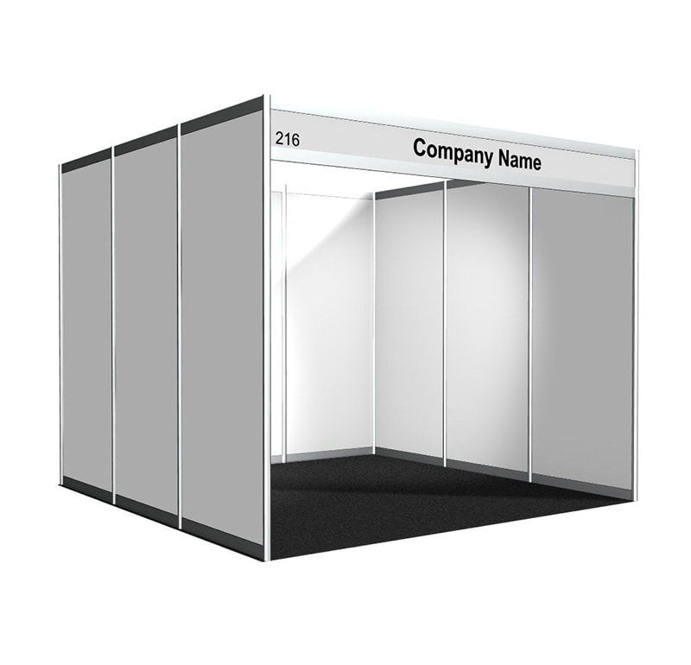

* Standard Shell Scheme Design **(1 side open)**

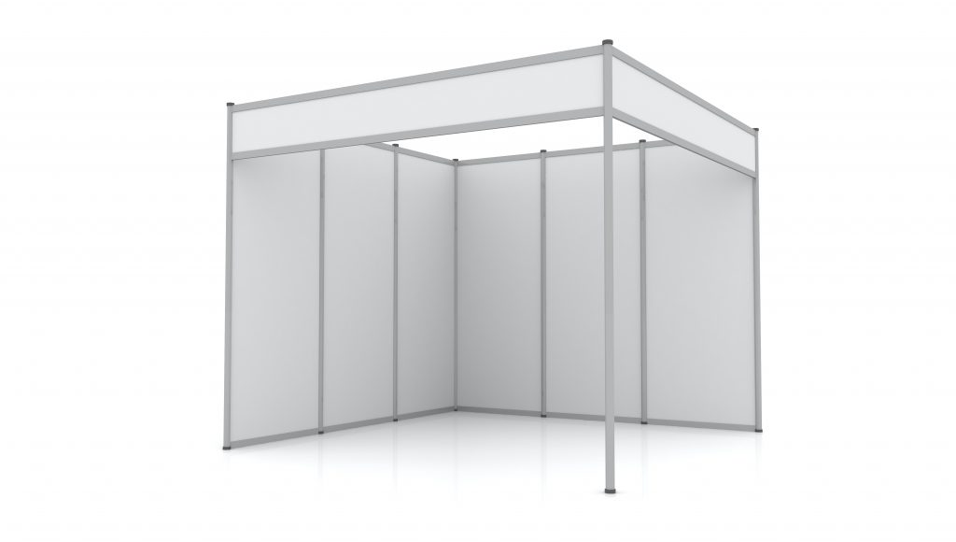

* Standard Shell Scheme Design **(2 side open)**

**Shell Scheme Graphic Type**

*(Most of the Shell Scheme are all 1 side open except for some that is located at the corner of each block are 2 sided open)*

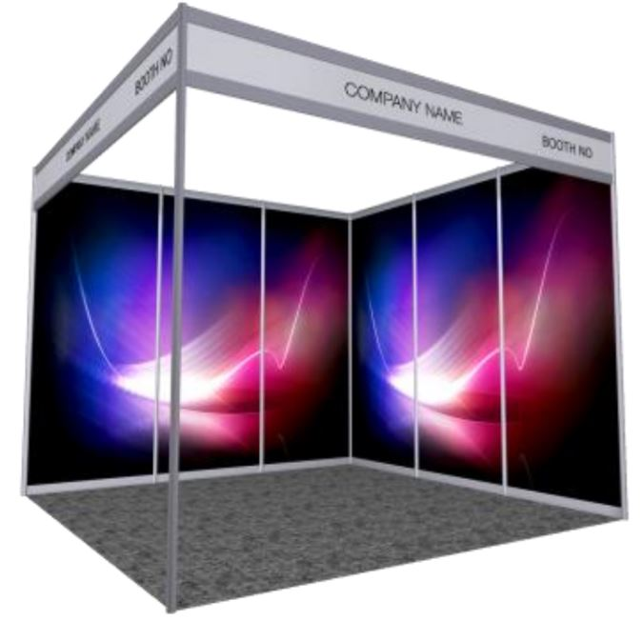

Sticker Print on each Panel

* 6nos. Panel for 2 sided open booth
* 9nos. Panel for 1 sided open booth

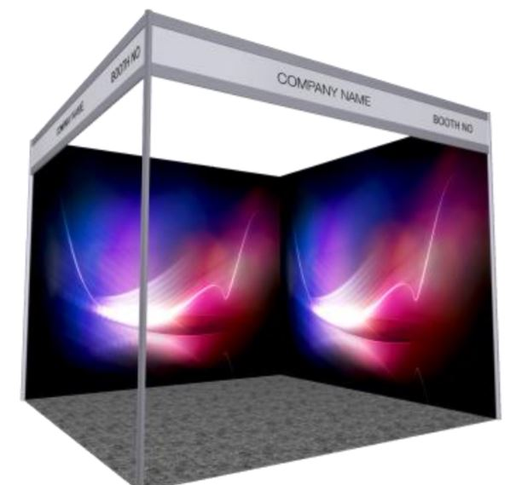

Sticker Print on Foamboard

* 2 side Full Panel Print for 2 sided open booth
* 3 side Full Panel Print for 1 sided open booth

**\*All graphic working file to be provided by the exhibitor**

**Shell Scheme Graphic Dimension**

*(Most of the Shell Scheme are all 1 side open except for some that is located at the corner of each block are 2 sided open)*



Sticker Print on each Panel

* 950mmW x 2350mmH



Dimension Sticker Print on Foamboard on each side

* 3010mmW x 2470mmH

**\*All graphic working file to be provided by the exhibitor**



**Service Form**



KUALA LUMPUR CONVENTION CENTRE EXHIBITOR ONLINE ORDER FORMS 2022

The KL Convention Centre order form is on line now. To access to the system, kindly follow the below step-by step guide:

1. Click on [Kuala Lumpur Convention Centre Exhibitor Online Order](https://klcc.ungerboeck.net/prod/app85.cshtml?aat=YF9enhUQuwsU7RgbQ7ACf8RQBjfxCdsXs59f9DuekuE%3d) **Forms 2022** and Sign-Up

2. Complete required details as a new user on your first visit to the site

3. Key in your booth/stand number and click “Ok”

4. You will be taken to the homepage to browse and purchase products and services and pay online (as well as the incentive rate deadline)

5. Your order will be sent directly to our teams to process in readiness and you will also receive an email confirmation

